Linux Programming: Assignment-3:
Name : Vigneshwaran P
Class : 3C
USN : ENG24CY0069
DATE : 27/09/2025

- Distinguish between man and whatis commands? Justify with proper example.
Soln:
man command :
The man command displays manual pages.
Syntax: man [options] command

Whatis command :
Gives a one-line short description.
Example: whatis ls → “ls (1) – list directory contents”.

- Use the tee command to save the output of ls -l into a file while also displaying it.
Soln:
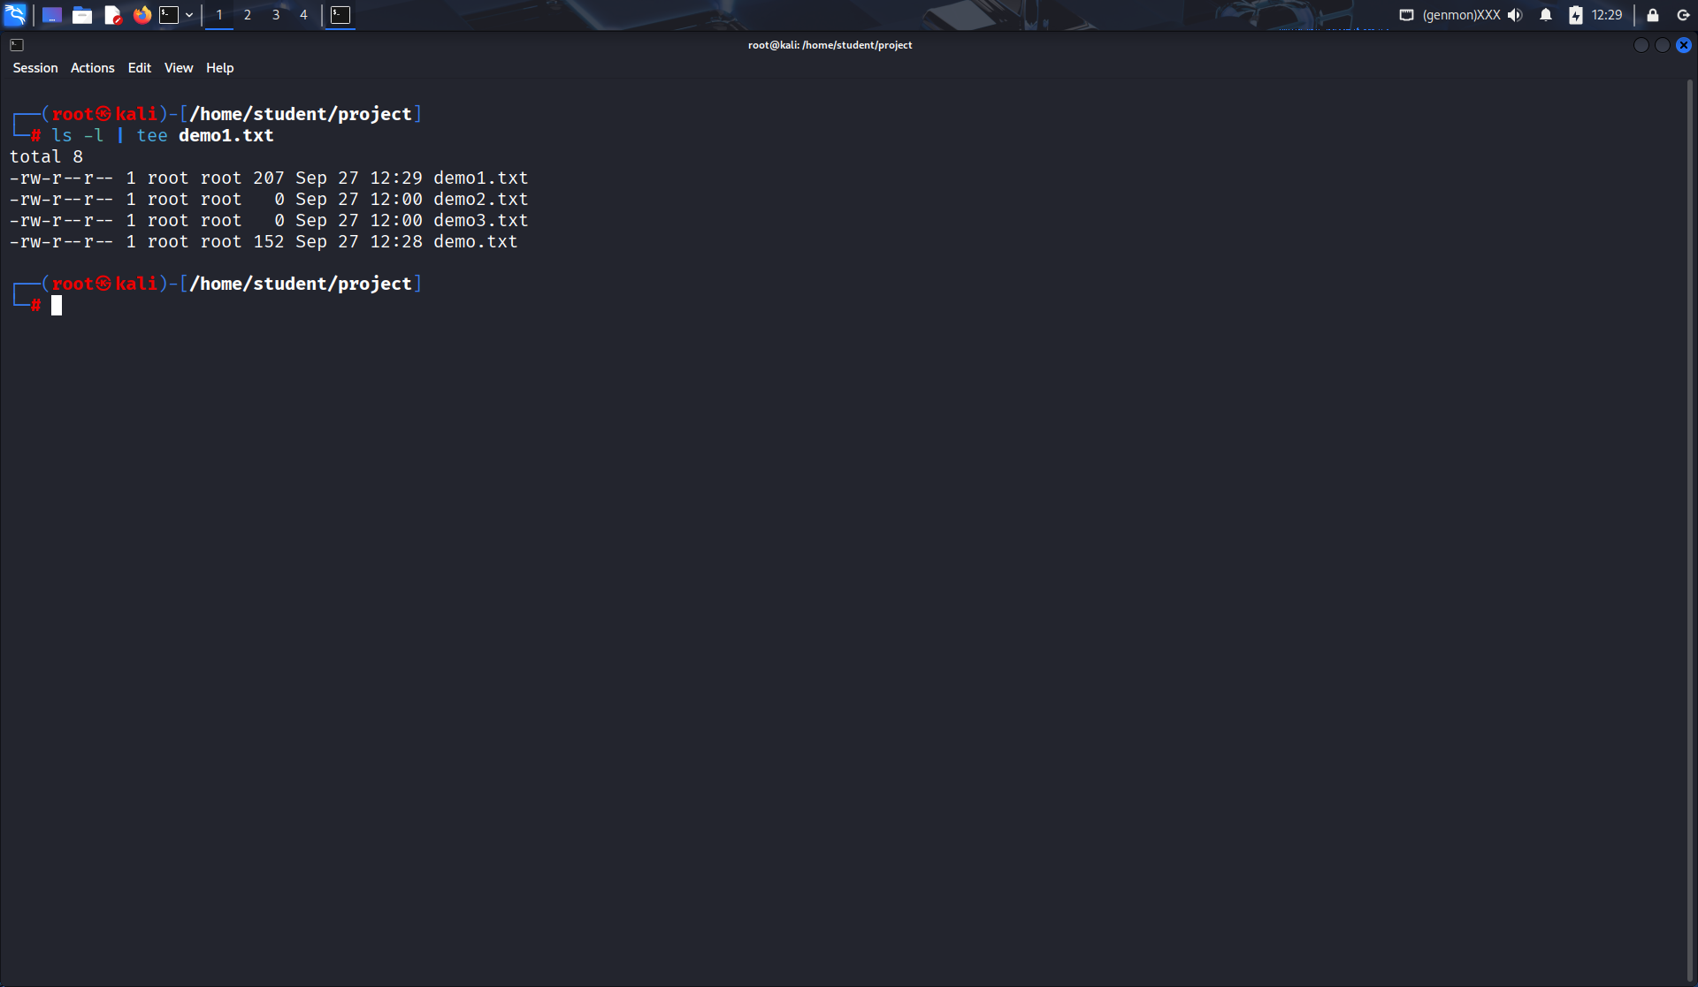
- Explain with an example how the tee command can be used in logging.
Soln:
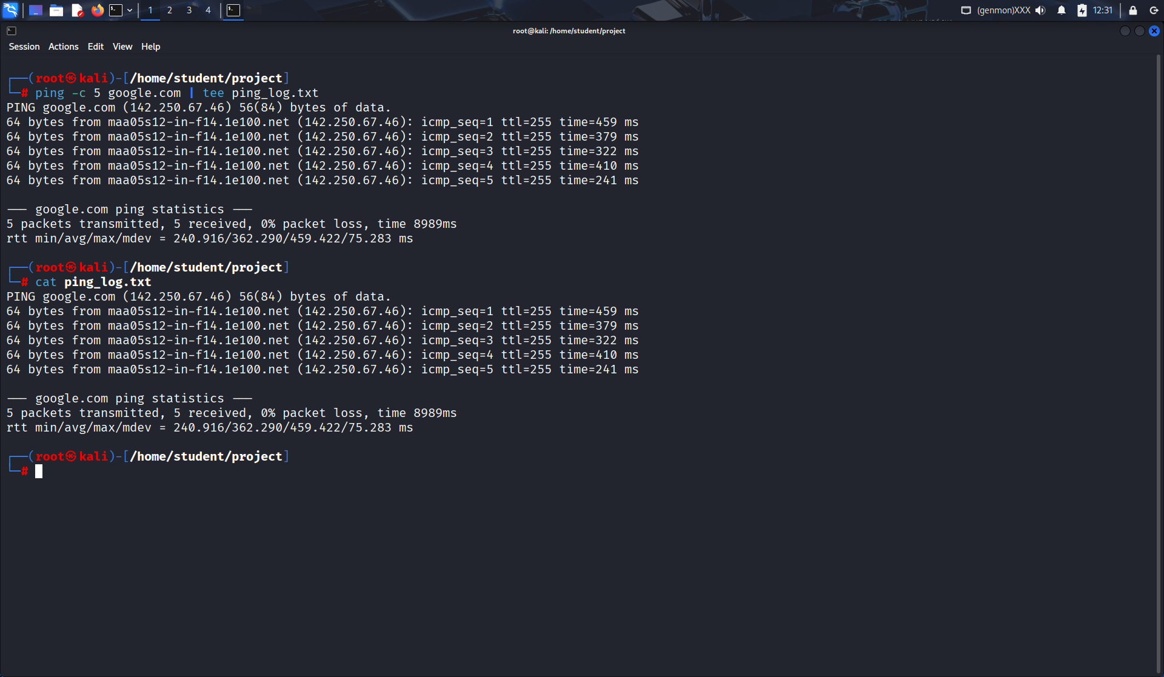
- List the steps involved in installing Ubuntu 25.04 LTS on Oracle VirtualBox.
Soln:

- Download ISO of Ubuntu 25.04 LTS.
- Install and open Oracle VirtualBox.
- Click New VM → Name: Ubuntu25.04.
- Allocate RAM (at least 2–4 GB) and storage (20 GB+).
- Attach ISO file as virtual optical disk.
- Start VM → Boot from ISO → Select “Install Ubuntu”.
- Follow installation wizard (language, keyboard, partition, user).
- Finish setup and restart VM.
- During Ubuntu OS installation, you face a Kernel Panic Error. How would you troubleshoot it?
Soln:
- Check ISO integrity (verify checksum).
- Allocate enough RAM/CPU in VirtualBox.
- Enable VT-x/AMD-V in BIOS.
- Use “Safe graphics mode” in installer.
- Update VirtualBox to latest version.
- Write the command to display the system’s hostname? How to change hostname using sysctl command?
Soln:
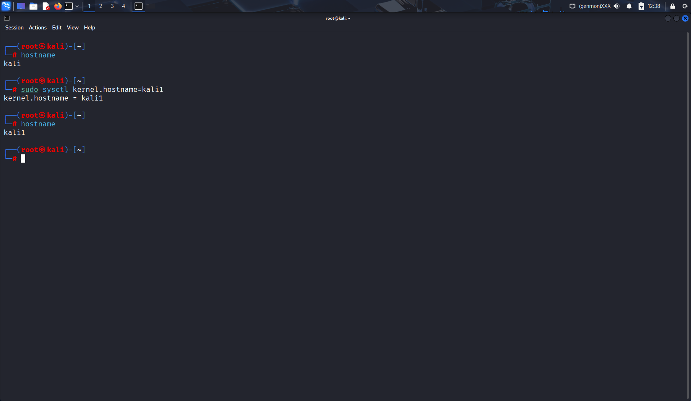
- Which command is used to show the calendar of the year 1984 with August month?
Soln:
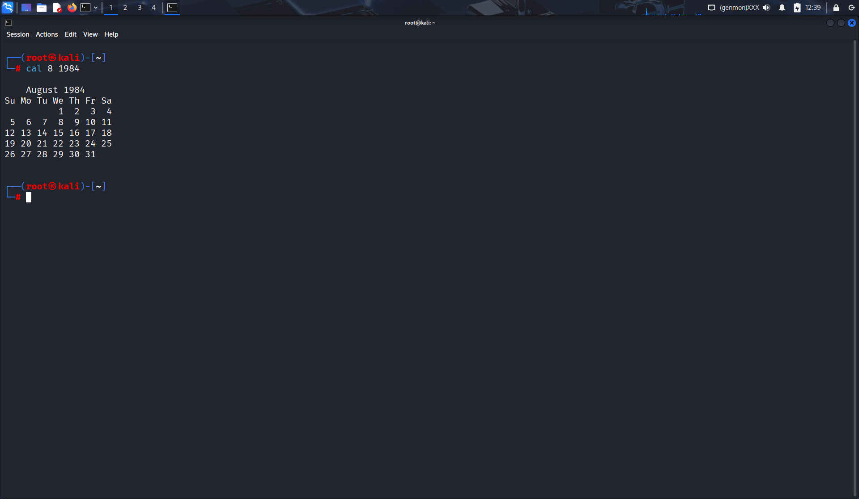

- Write a command to display system uptime and logged-in users together.
Soln:
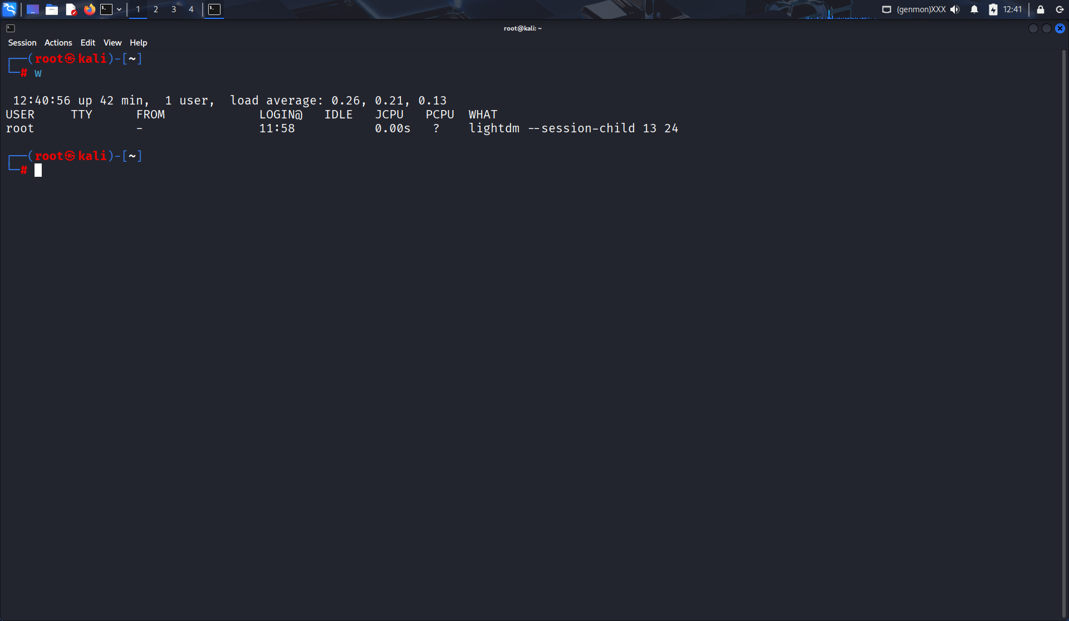

- Use the find command to list all “.c” files in /home/user
Soln:
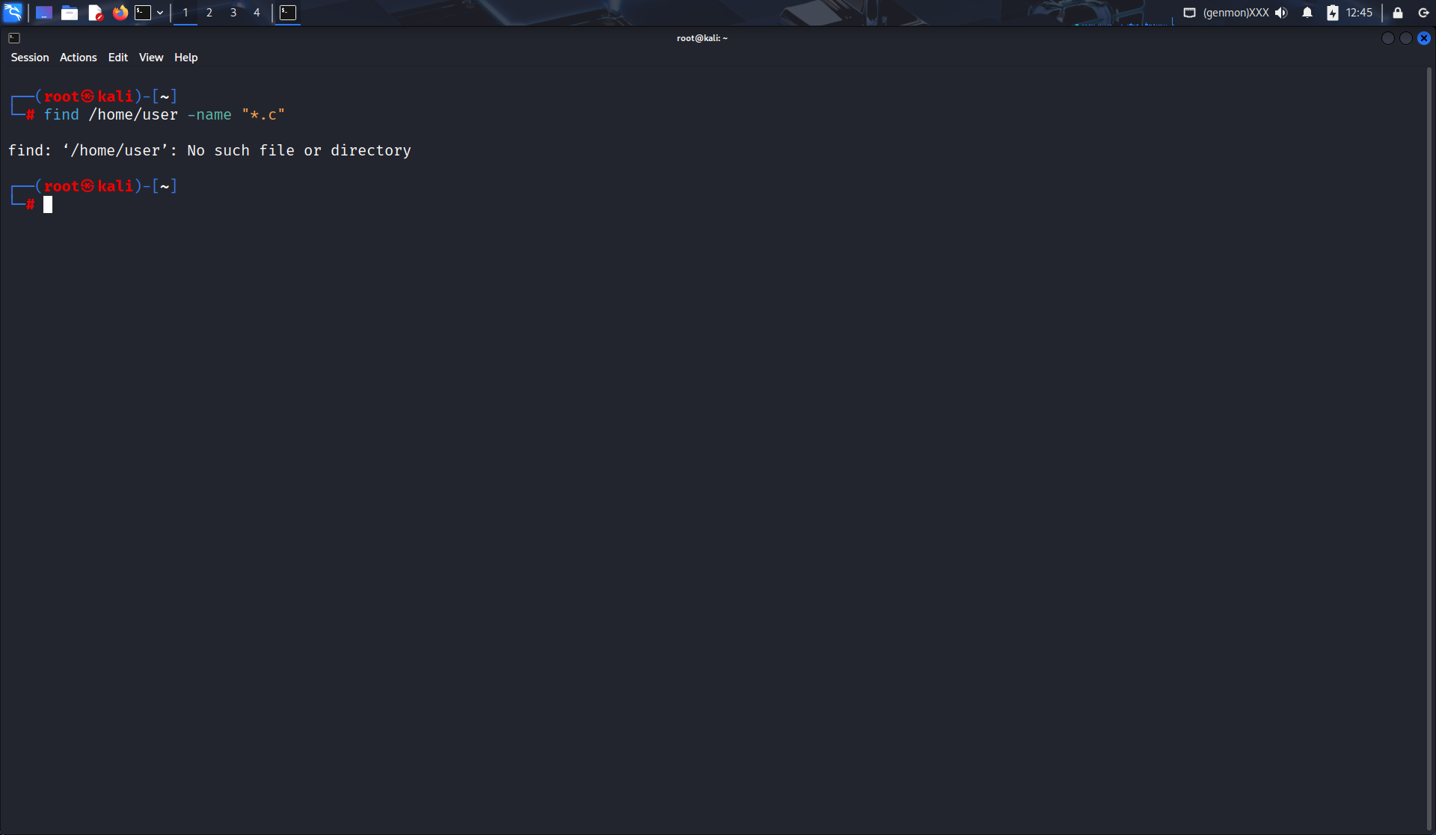

- How do you change file permissions to allow only the owner to read and write?
Soln:
chmod 600{ filename}

